Student Work Booklet

Week 1, Cyber Security Fundamentals

Topic: Value of Data

Activity: Cyber Security Fundamentals

What is Cyber Security?
____________________________________________________________________________________________________________________________________________________________________________________________________________________________________________________________________________________________________________

Why is it important?
____________________________________________________________________________________________________________________________________________________________________________________________________________________________________________________________________________________________________________

Whom does cyber security affect?
____________________________________________________________________________________________________________________________________________________________________________________________________________________________________________________________________________________________________________

Activity: 15 Cyber Security Terms You Should Know
Match the terms to the correct definition from Video 1.1.3 - 15 Cyber Security Terms You Should Know, then provide your own real example.
Term | Definition | Example
User Authentication
Encryption
Anti-Virus
Malware
Firewall
Phishing
Multi-Factor Authentication
Denial of Service (DoS/DDoS)
Ethical Hacking
Ransomware
Cyber Attack
Cloud
Network
IoT (Internet of Things)
Penetration Test

Class Brainstorm: What is the difference (and similarities) between data and information?

Class Discussion: Data

What is Data?
____________________________________________________________________________________________________________________________________________________________________________________________________________________________________________________________________________________________________________

What is Information?
____________________________________________________________________________________________________________________________________________________________________________________________________________________________________________________________________________________________________________

What makes data valuable?
____________________________________________________________________________________________________________________________________________________________________________________________________________________________________________________________________________________________________________

Value in data, Value from data, and value of data Do these three statements mean the same thing? Why/Why not?
____________________________________________________________________________________________________________________________________________________________________________________________________________________________________________________________________________________________________________

How does data have different values in different contexts?
____________________________________________________________________________________________________________________________________________________________________________________________________________________________________________________________________________________________________________

How does this change human behaviour to the items of value?
____________________________________________________________________________________________________________________________________________________________________________________________________________________________________________________________________________________________________________

Topic: Ethics

Please answer the following questions per each scenario.

Scenario 1

Michael is an employee of Racer Athletic Wear, he has taken a photo in the company’s clothes and has advertised the clothing and tagged the brand, captioning the post with a deal that the company currently has is not worth it, even though someone with a company discount, he regrets making the purchase. He has posted the image to his personal social media; the company has asked for the employee to take it down.
Who owns the data?
_______________________________________________________________________________________________________________________________________________________________________________________________________________________________________________________________________________________________________________________________________
Who has the ethical responsibility to protect it?
_______________________________________________________________________________________________________________________________________________________________________________________________________________________________________________________________________________________________________________________________________
Is the behaviour of each party fair and ethical?
____________________________________________________________________________________________________________________________________________________________________________________________________________________________________________________________________________________________________________
Would your answers change if he was advertising the company in a positive way? If so why/why not?
_______________________________________________________________________________________________________________________________________________________________________________________________________________________________________________________________________________________________________________________________________

What are the behaviours that would be considered ethical and non-ethical in the scenario?
_______________________________________________________________________________________________________________________________________________________________________________________________________________________________________________________________________________________________________________________________________

Identify the different parties in the scenario.
__________________________________________________________________________________________________________________________________________________________________________________________________________________________

Justify their point on what they considered as ethical and unethical behaviour in one of the scenarios.
_______________________________________________________________________________________________________________________________________________________________________________________________________________________________________________________________________________________________________________________________________
Were any illegal actions/behaviours present in the scenarios? If not, what factors could make these scenarios illegal?
_______________________________________________________________________________________________________________________________________________________________________________________________________________________________________________________________________________________________________________________________________
Scenario 2
Super Warehouse, has installed facial recognition technology to track customers when they are in the store. The technology captures and documents details such as the duration spent in-store and items bought without the customers’ knowledge or consent.

What are the behaviours that would be considered ethical and non-ethical in the scenario?
_______________________________________________________________________________________________________________________________________________________________________________________________________________________________________________________________________________________________________________________________________

Identify the different parties in the scenario.
__________________________________________________________________________________________________________________________________________________________________________________________________________________________

Justify their point on what they considered as ethical and unethical behaviour in one of the scenarios.
_______________________________________________________________________________________________________________________________________________________________________________________________________________________________________________________________________________________________________________________________________
Were any illegal actions/behaviours present in the scenarios? If not, what factors could make these scenarios illegal?
_______________________________________________________________________________________________________________________________________________________________________________________________________________________________________________________________________________________________________________________________________
Scenario 3:

The management of a band wants to modify the band's website to offer free concert tickets to its fans. To claim these free tickets, customers must register online and provide the management with their email and phone number. The management then sold these details to telemarketers, to make up for the concert ticket profit loss. Fans did sign terms and conditions before getting their free tickets.

What are the behaviours that would be considered ethical and non-ethical in the scenario?
_______________________________________________________________________________________________________________________________________________________________________________________________________________________________________________________________________________________________________________________________________

Identify the different parties in the scenario.
__________________________________________________________________________________________________________________________________________________________________________________________________________________________

Justify their point on what they considered as ethical and unethical behaviour in one of the scenarios.
_______________________________________________________________________________________________________________________________________________________________________________________________________________________________________________________________________________________________________________________________________
Were any illegal actions/behaviours present in the scenarios? If not, what factors could make these scenarios illegal?
_______________________________________________________________________________________________________________________________________________________________________________________________________________________________________________________________________________________________________________________________________

Topic: Privacy

Activity: Video Review
Using the knowledge from the video 1.3.2 The Mind Reader answer the following questions.

What data should be private?
_______________________________________________________________________________________________________________________________________________________________________________________________________________________________________________________________________________________________________________________________________

After watching the video, do you still think your previous data types should remain private, more? Less?
_______________________________________________________________________________________________________________________________________________________________________________________________________________________________________________________________________________________________________________________________________

Activity: Define Privacy Terms
Term | Definition
Privacy
Confidentiality
Disclosure
Anonymity
Security
Private Information
Public Information
Personally Identifiable Information (PII)
Persona
Identity Theft

What is the relationship between Privacy and Confidentiality?
_______________________________________________________________________________________________________________________________________________________________________________________________________________________________________________________________________________________________________________________________________

What is the relationship between Privacy and Anonymity?
_______________________________________________________________________________________________________________________________________________________________________________________________________________________________________________________________________________________________________________________________________

What is the relationship between PII and social identity?
_______________________________________________________________________________________________________________________________________________________________________________________________________________________________________________________________________________________________________________________________________

What are the issues with publishing private information?
_______________________________________________________________________________________________________________________________________________________________________________________________________________________________________________________________________________________________________________________________________

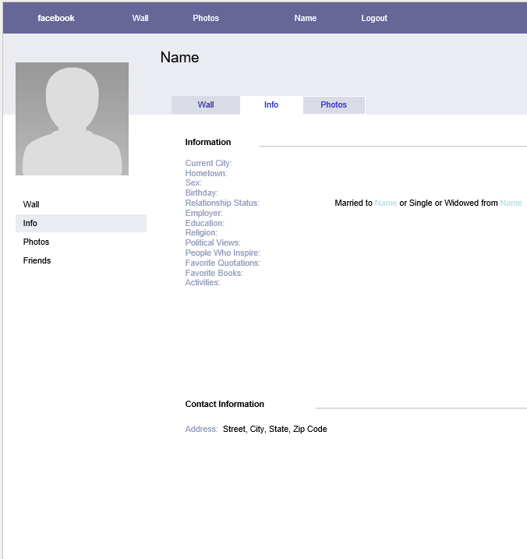
Mimicking your own social media or how you would fill it out, fill out your ‘social media page’ of what is suitable to post. Label which parts can be private to friends or public for the world.

Reference: Blank Facebook Template - 13+ Free Word, PPT & PSD Documents Download

Why have you made these choices?
_______________________________________________________________________________________________________________________________________________________________________________________________________________________________________________________________________________________________________________________________________

Is there a violation of privacy?
_______________________________________________________________________________________________________________________________________________________________________________________________________________________________________________________________________________________________________________________________________

Summary of Week 1 - Create your own notes, understandings, definitions etc..

_______________________________________________________________________________________________________________________________________________________________________________________________________________________________________________________________________________________________________________________________________
_______________________________________________________________________________________________________________________________________________________________________________________________________________________________________________________________________________________________________________________________________
___________________________________________________________________________________________________________________________________________________________________________________________________________________________________________________________________________________________________________________________________________________________________________________________________________________________________________________________________________________________________________________________________________________________________________________________________________________________________________________________________________________________________________________________________________________________________________________________

Summary of Week 1 – Create your own drawings, symbols, diagrams, visual notes etc.

