Student Work Booklet

Week 3, Protecting Data

Topic: Authentication

Research Activity
Research modern examples of an authentication type.
Hint: Password-based authentication. Multi-factor authentication. Certificate-based authentication. Biometric authentication. Token-based authentication.
What type of authentication are you reporting on? _________________________________________________________________
How does it work?
__________________________________________________________________________________________________________________________
__________________________________________________________________________________________________________________________
__________________________________________________________________________________________________________________________

Examples of who may use it and why?
__________________________________________________________________________________________________________________________
__________________________________________________________________________________________________________________________
__________________________________________________________________________________________________________________________

Topic: Threats

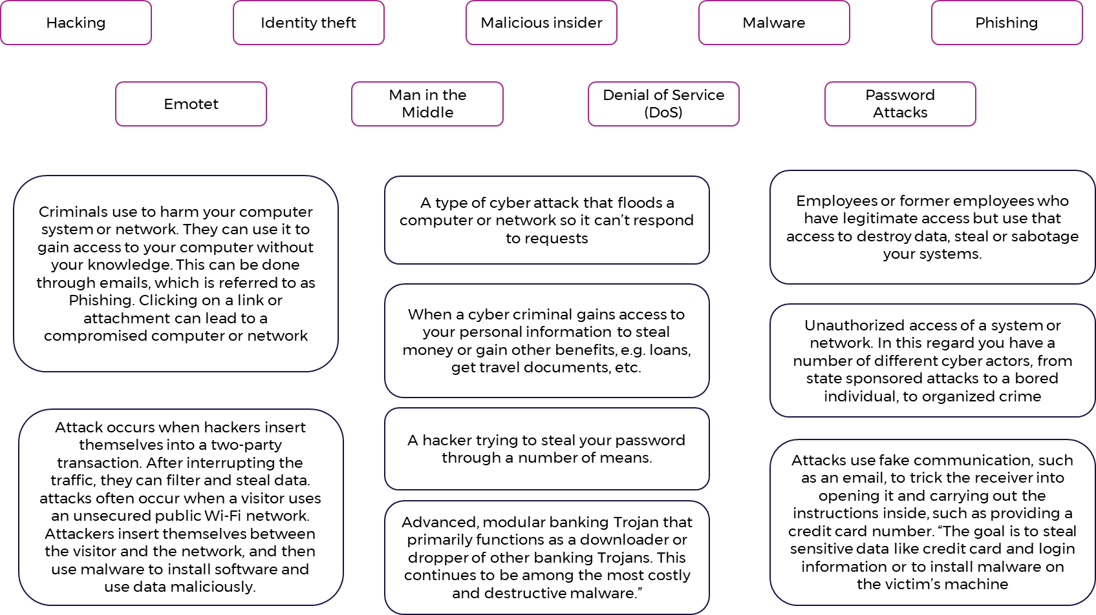
Activity: Match Up

Are threats always visible?
______________________________________________________________________________________________________________________________________________________________________________________________________________________________________________________________________________________________________________________________________________________________________________
Can they be avoided or controlled?
______________________________________________________________________________________________________________________________________________________________________________________________________________________________________________________________________________________________________________________________________________________________________________

Topic: Vulnerabilities & Risks

Activity: Student Questions

How do protection levels affect the vulnerability of losing security?
__________________________________________________________________________________________________________________________
__________________________________________________________________________________________________________________________
__________________________________________________________________________________________________________________________

Research Activity
Students use technology to research modern examples of breaches, including but not limited to:
- LinkedIn breach
- Yahoo breach
- Facebook breach
- Medibank data breach
Breach example chosen: ___________________________________________________________________________________________

Evaluate the impact of the cyber security breach on:

- The Business/organization

____________________________________________________________________________________________________________________

____________________________________________________________________________________________________________________

____________________________________________________________________________________________________________________

- Their clients or users

____________________________________________________________________________________________________________________

____________________________________________________________________________________________________________________

____________________________________________________________________________________________________________________

Why was the business/organisation a target?

__________________________________________________________________________________________________________________________

__________________________________________________________________________________________________________________________
How could the business/organisation company minimise vulnerabilities?
______________________________________________________________________________________________________________________________________________________________________________________________________________________________________________________________________________________________________________________________________________________________________________
Can vulnerabilities be controlled?
______________________________________________________________________________________________________________________________________________________________________________________________________________________________________________________________________________________________________________________________________________________________________________
Were third parties (clients, users, partners) affected by a breach? Choose one and discuss the impacts of the breach relating to them.
__________________________________________________________________________________________________________________________
__________________________________________________________________________________________________________________________
__________________________________________________________________________________________________________________________

Summary of Week 3 - Create your own notes, understandings, definitions etc..

__________________________________________________________________________________________________________________________
______________________________________________________________________________________________________________________________________________________________________________________________________________________________________________________________________________________________________________________________________________________________________________
______________________________________________________________________________________________________________________________________________________________________________________________________________________________________________________________________________________________________________________________________________________________________________________________________________________________________________________________________________________________________________________________________________________________________________________________________________________________________________________________________________________________________________________________________________________________________________________________________________________________________________________________________________________

Summary of Week 2 – Create your own drawings, symbols, diagrams, visual notes etc.

